1-Broadcast

📡 What Is Broadcast?
# Source: AI Source: Provided by: [Data Path: Persons Table -> ID Column: 1, Name_En Column: Motasem Essam] -> From: [Chatgpt (GPT‑5 Mini)] on [1/21/2026]
Broadcast is a method of communication where a single message is sent to multiple recipients at the same time — typically to everyone in a specific area or network.
🧠 Think of it like a radio station: one signal, many listeners.

📲 In Telecommunications:
# Source: AI Source: Provided by: [Data Path: Persons Table -> ID Column: 1, Name_En Column: Motasem Essam] -> From: [Chatgpt (GPT‑5 Mini)] on [1/21/2026]
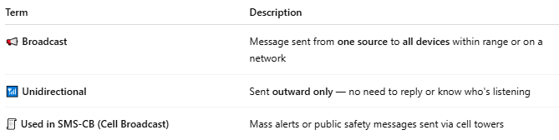

Term | Description
📢 Broadcast | Message sent from one source to all devices within range or on a network
📶 Unidirectional | Sent outward only — no need to reply or know who's listening
🧾 Used in SMS-CB (Cell Broadcast) | Mass alerts or public safety messages sent via cell towers

🔁 Broadcast vs Other Communication Types:
# Source: AI Source: Provided by: [Data Path: Persons Table -> ID Column: 1, Name_En Column: Motasem Essam] -> From: [Chatgpt (GPT‑5 Mini)] on [1/21/2026]
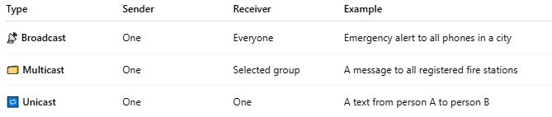

Type | Sender | Receiver | Example
📡 Broadcast | One | Everyone | Emergency alert to all phones in a city
🗂️ Multicast | One | Selected group | A message to all registered fire stations
🔁 Unicast | One | One | A text from person A to person B

🧠 Real-World Examples of Broadcast:
# Source: AI Source: Provided by: [Data Path: Persons Table -> ID Column: 1, Name_En Column: Motasem Essam] -> From: [Chatgpt (GPT‑5 Mini)] on [1/21/2026]
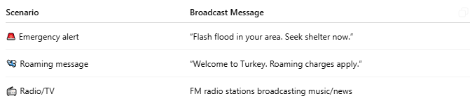

Scenario | Broadcast Message
🚨 Emergency alert | “Flash flood in your area. Seek shelter now.”
🛬 Roaming message | “Welcome to Turkey. Roaming charges apply.”
📻 Radio/TV | FM radio stations broadcasting music/news

📦 Where Broadcast Is Used in Tech:
# Source: AI Source: Provided by: [Data Path: Persons Table -> ID Column: 1, Name_En Column: Motasem Essam] -> From: [Chatgpt (GPT‑5 Mini)] on [1/21/2026]
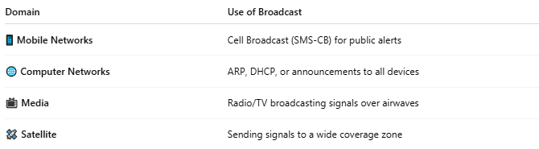

Domain | Use of Broadcast
📱 Mobile Networks | Cell Broadcast (SMS-CB) for public alerts
🌐 Computer Networks | ARP, DHCP, or announcements to all devices
📺 Media | Radio/TV broadcasting signals over airwaves
🛰️ Satellite | Sending signals to a wide coverage zone

📖 Summary:
# Source: AI Source: Provided by: [Data Path: Persons Table -> ID Column: 1, Name_En Column: Motasem Essam] -> From: [Chatgpt (GPT‑5 Mini)] on [1/21/2026]
- Broadcast = One-to-many communication
- Used when the same information needs to reach many users at once
- Common in emergency systems, media, and mobile alerts
- Unlike regular SMS, broadcast does not target specific individuals

2-Multicast

🗂️ What Is Multicast?
# Source: AI Source: Provided by: [Data Path: Persons Table -> ID Column: 1, Name_En Column: Motasem Essam] -> From: [Chatgpt (GPT‑5 Mini)] on [1/21/2026]
Multicast is a method of communication where data is sent from one sender to a specific group of receivers, not to everyone, and not just one person.
🧠 Think of multicast like a group chat — one person sends a message, and only certain members of the group get it.

🎯 Key Features:
# Source: AI Source: Provided by: [Data Path: Persons Table -> ID Column: 1, Name_En Column: Motasem Essam] -> From: [Chatgpt (GPT‑5 Mini)] on [1/21/2026]
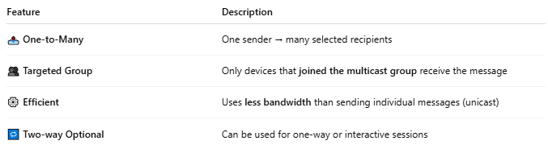

Feature | Description
📤 One-to-Many | One sender → many selected recipients
👥 Targeted Group | Only devices that joined the multicast group receive the message
⚙️ Efficient | Uses less bandwidth than sending individual messages (unicast)
🔁 Two-way Optional | Can be used for one-way or interactive sessions

🧩 Multicast in Different Domains:
# Source: AI Source: Provided by: [Data Path: Persons Table -> ID Column: 1, Name_En Column: Motasem Essam] -> From: [Chatgpt (GPT‑5 Mini)] on [1/21/2026]
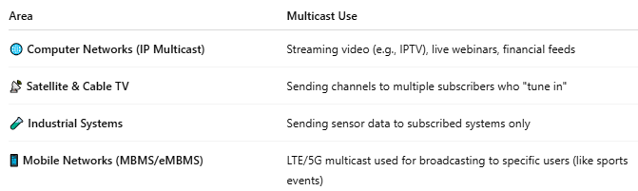

Area | Multicast Use
🌐 Computer Networks (IP Multicast) | Streaming video (e.g., IPTV), live webinars, financial feeds
📡 Satellite & Cable TV | Sending channels to multiple subscribers who "tune in"
🧪 Industrial Systems | Sending sensor data to subscribed systems only
📱 Mobile Networks (MBMS/eMBMS) | LTE/5G multicast used for broadcasting to specific users (like sports events)

🔁 Multicast vs Other Modes:
# Source: AI Source: Provided by: [Data Path: Persons Table -> ID Column: 1, Name_En Column: Motasem Essam] -> From: [Chatgpt (GPT‑5 Mini)] on [1/21/2026]
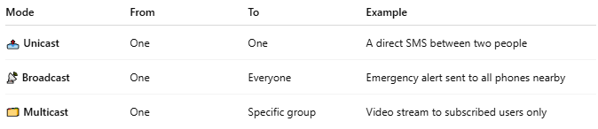

Mode | From | To | Example
📤 Unicast | One | One | A direct SMS between two people
📡 Broadcast | One | Everyone | Emergency alert sent to all phones nearby
🗂️ Multicast | One | Specific group | Video stream to subscribed users only

🌐 IP Multicast (Example):
# Source: AI Source: Provided by: [Data Path: Persons Table -> ID Column: 1, Name_En Column: Motasem Essam] -> From: [Chatgpt (GPT‑5 Mini)] on [1/21/2026]
In IP networks:
- Devices join a multicast group (e.g., 239.1.2.3)
- The sender transmits the message once
- The network delivers it only to the subscribed receivers

✅ Benefits of Multicast:
# Source: AI Source: Provided by: [Data Path: Persons Table -> ID Column: 1, Name_En Column: Motasem Essam] -> From: [Chatgpt (GPT‑5 Mini)] on [1/21/2026]
- 📉 Reduces bandwidth usage (better than sending same data to each person separately)
- ⚡ Low latency for group delivery
- 📡 Ideal for live content, updates, and group services

📖 Summary:
# Source: AI Source: Provided by: [Data Path: Persons Table -> ID Column: 1, Name_En Column: Motasem Essam] -> From: [Chatgpt (GPT‑5 Mini)] on [1/21/2026]
- Multicast is one-to-many, but targeted (not public like broadcast)
- Used in streaming, conferencing, and group messaging
- More efficient than unicast when sending to many users
- Not all devices receive it — only those that subscribe or join the group

3-Unicast

🔁 What Is Unicast?
# Source: AI Source: Provided by: [Data Path: Persons Table -> ID Column: 1, Name_En Column: Motasem Essam] -> From: [Chatgpt (GPT‑5 Mini)] on [1/21/2026]
Unicast is a type of communication where data is sent from one device to exactly one other device — it's one-to-one communication.
📱 Think of it like a private conversation between two people. Only the sender and receiver are involved.

📤 Example Scenarios:
# Source: AI Source: Provided by: [Data Path: Persons Table -> ID Column: 1, Name_En Column: Motasem Essam] -> From: [Chatgpt (GPT‑5 Mini)] on [1/21/2026]
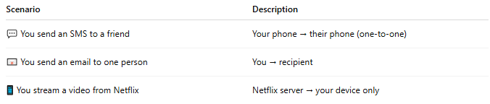

Scenario | Description
💬 You send an SMS to a friend | Your phone → their phone (one-to-one)
📧 You send an email to one person | You → recipient
📱 You stream a video from Netflix | Netflix server → your device only

🧩 Characteristics of Unicast:
# Source: AI Source: Provided by: [Data Path: Persons Table -> ID Column: 1, Name_En Column: Motasem Essam] -> From: [Chatgpt (GPT‑5 Mini)] on [1/21/2026]
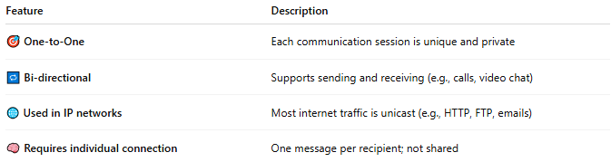

Feature | Description
🎯 One-to-One | Each communication session is unique and private
🔁 Bi-directional | Supports sending and receiving (e.g., calls, video chat)
🌐 Used in IP networks | Most internet traffic is unicast (e.g., HTTP, FTP, emails)
🧠 Requires individual connection | One message per recipient; not shared

🔁 Unicast vs Broadcast vs Multicast:
# Source: AI Source: Provided by: [Data Path: Persons Table -> ID Column: 1, Name_En Column: Motasem Essam] -> From: [Chatgpt (GPT‑5 Mini)] on [1/21/2026]
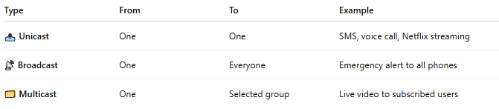

Type | From | To | Example
📤 Unicast | One | One | SMS, voice call, Netflix streaming
📡 Broadcast | One | Everyone | Emergency alert to all phones
🗂️ Multicast | One | Selected group | Live video to subscribed users

⚙️ In Networking (IP Unicast):
# Source: AI Source: Provided by: [Data Path: Persons Table -> ID Column: 1, Name_En Column: Motasem Essam] -> From: [Chatgpt (GPT‑5 Mini)] on [1/21/2026]
- Each device has a unique IP address
- Unicast traffic is directed to that specific IP
- The sender must duplicate the message if it wants to reach multiple people (unlike multicast)

✅ Benefits of Unicast:
# Source: AI Source: Provided by: [Data Path: Persons Table -> ID Column: 1, Name_En Column: Motasem Essam] -> From: [Chatgpt (GPT‑5 Mini)] on [1/21/2026]
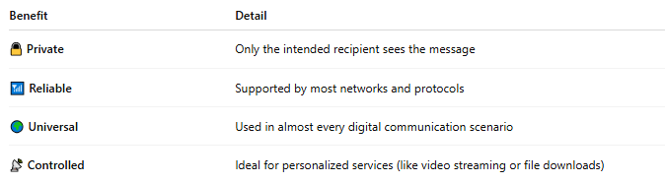

Benefit | Detail
🔒 Private | Only the intended recipient sees the message
📶 Reliable | Supported by most networks and protocols
🌍 Universal | Used in almost every digital communication scenario
📡 Controlled | Ideal for personalized services (like video streaming or file downloads)

📖 Summary:
# Source: AI Source: Provided by: [Data Path: Persons Table -> ID Column: 1, Name_En Column: Motasem Essam] -> From: [Chatgpt (GPT‑5 Mini)] on [1/21/2026]
Unicast is:
- 🔁 One-to-one communication
- 📩 Used for SMS, voice calls, streaming, web browsing
- 🔒 Private and direct
- The most common communication type on mobile and internet networks

